Climate-Resilient Food Manufacturing: Integrating Smart Agriculture with Advanced Food Processing

From Farm Resilience to Global Market Readiness
By OJ Lopez, Chief Strategy & Growth Officer, Envi-Comm Corporation
The Philippines has a food-security problem, but we believe we also have a food-industry opportunity.
The question is no longer simply: How do we produce more food?
The bigger question is:
How do we build a Philippine food system that can produce reliably, process efficiently, withstand climate shocks, meet increasingly demanding environmental and food-safety requirements, and compete globally?
That requires us to stop thinking about agriculture and food manufacturing as separate industries.
The farm is the first factory of the food economy.
What happens on the farm eventually affects the factory, the cold chain, the processor, the exporter, the consumer and ultimately the country's competitiveness.
As Chief Strategy Officer of Envi-Comm, my perspective is shaped by working at the intersection of environmental compliance, agriculture, manufacturing, engineering, technology and sustainability. Envi-Comm's mission is to help organizations go beyond environmental compliance and accelerate the transition to a sustainable future through an ecosystem of expertise, technology and ESG solutions.
And for us, climate resilience is where these pieces finally come together.

What’s Happening on the Ground
Before we talk about smart agriculture and advanced food processing, we need to look at what is happening on the ground.
Many small farmers still practice mono-cropping, planting what their neighbors are planting because there is little access to real-time market information. Everyone produces the same crop, harvests around the same time, and then competes for the same buyers.
When supply is high, prices drop. Farmers are forced to sell at low prices, and in some cases, produce is left to spoil or is thrown away because there is no immediate market, storage, or processing option.
The problem is not simply that farmers are producing too little.
The problem is that we are not connecting production to demand.
Very few farmers are also connected to food processing opportunities. Instead of selling only fresh produce, we could be transforming more of it into salad kits, smoothies, juices, frozen products, dried products, sauces, and other higher-value foods.
This creates another pathway for farmers and reduces dependence on the fresh market.
For us, this is where Smart Agriculture meets Advanced Food Processing.
We need to move from “plant first, find a buyer later” to “understand the market, produce intelligently, process efficiently, and create value.”
That is how we make agriculture more resilient. For the farmer, the processor, and ultimately the Filipino consumer.

The Philippines is simultaneously an agricultural producer and a major agricultural importer
We need to begin with an uncomfortable reality.
In 2024, the Philippines recorded US$19.46 billion in agricultural imports, compared with US$7.75 billion in agricultural exports. That produced an agricultural trade deficit of US$11.71 billion. Agricultural imports represented 71.5% of total agricultural trade.
This does not mean that we import most of the food we consume. That would be an inaccurate conclusion.
But it does tell us something important:
We have significant dependencies on imported agricultural commodities and raw materials.
Three of our largest agricultural import products in 2024 were:
Commodity | Import Value | Volume
Rice | US$2.45B | 4.77M MT
Wheat | US$1.85B | 6.84M MT
Soybean oil/copra cake | US$1.45B | 3.15M MT
Together, these three commodities represented approximately US$5.75 billion in imports.
And the country dependencies are revealing.
For rice, for example, Vietnam supplied about 72% of the Philippines' 2024 rice import value, followed by Thailand at about 13%.
That is not necessarily bad. International trade is part of a modern food system.
The vulnerability comes when we have limited domestic alternatives, concentrated sources, weak buffers, climate-sensitive production, and insufficient processing capacity at the same time.
That is when a climate event, disease outbreak, logistics disruption, export restriction or international price shock can quickly become a food-security problem.
But we should not define the Philippines only by what we import
There is another side of the story.
The Philippines exported US$7.75 billion worth of agricultural products in 2024, up 20.6% from 2023.
Our leading agricultural export products included:
- Coconut oil — US$2.25 billion
- Fresh bananas — US$1.23 billion
- Pineapple and products — US$788.3 million
The coconut story is particularly important.
The Philippine Coconut Authority's 2024 industry profile describes the Philippines as the world's No. 1 coconut exporter, with approximately US$2 billion in average annual export revenue, 3.6 million hectares devoted to coconut and around 2.8 million registered farmers and farm workers. At the same time, it ranks the Philippines as the world's No. 3 coconut producer.
That distinction teaches us an important economic lesson:
We don't always have to be the world's largest producer to become a global leader.
We can create enormous value through processing, quality, logistics, technology, traceability and access to global markets.
That is precisely where advanced food manufacturing becomes strategically important.
The banana story is another lesson in resilience
The Philippine banana industry provides perhaps the clearest example of both the opportunity and the vulnerability of our agricultural economy.
In 2024, Philippine banana exports were approximately 2.33 million metric tons, and the Philippines ranked third globally.
But in 2025, the country recovered strongly.
Preliminary FAO data reported that Philippine banana exports rose 25.6% to approximately 2.93 million metric tons, returning the Philippines to No. 2 globally behind Ecuador and maintaining its position as the leading exporter in Asia.
Why does this matter?
Because the recovery was not simply a story about planting more bananas.
It involved: investment, recovery from disease and weather damage, improved production, agricultural inputs, soil-health interventions, biological controls, and renewed market demand.
The Department of Agriculture reported that its programs included the distribution of planting materials, organic fertilizer and biological control agents to strengthen production and resilience.
This is a very important model.
Climate resilience is not simply about surviving climate change.
It is about building a production system that can recover faster, adapt faster and maintain market access.
The problem is that the farm and the factory are still too disconnected
This is where I believe the Philippines needs a strategic shift.
Today, we often discuss: Smart Agriculture
and separately: Food Manufacturing
and separately: Environmental Compliance
and separately: Export Promotion
and separately: Climate Action.
But the global market doesn't see these as separate.
A global buyer sees one supply chain.
The buyer asks:
- Where did the raw material come from?
- Was it produced safely?
- Can you trace it?
- Was it handled properly?
- Was it processed under controlled conditions?
- What happened to the waste?
- How reliable is the supplier?
- Can you prove compliance?
- Can you maintain quality consistently?
- Can you demonstrate responsible environmental practices?
That is the real meaning of farm-to-factory-to-market resilience.
Global export compliance is becoming a data problem
We need to understand where international markets are heading.
The European Union, for example, requires traceability throughout the food chain and applies risk-based official controls to imported food and feed. Imported products must meet the relevant safety, quality and traceability requirements, with additional certification and border controls applying to certain products, particularly products of animal origin and specified high-risk goods.
The United States has taken a similar preventive approach.
Under the FDA's Foreign Supplier Verification Program, covered importers must perform risk-based activities to verify that foreign suppliers produce food in a manner consistent with applicable U.S. safety requirements. This includes hazard analysis, supplier evaluation, verification activities and corrective actions.
So when we talk about global export regulations, we should not think about one universal regulation.
There isn't one.
Different markets have different requirements.
But there is a common direction:
Global food trade is moving toward prevention, traceability, verification and documented evidence.
This is why I often say:
The future of compliance is not more paperwork. It is better data.
Compliance should begin before the export opportunity
This is where I see a major opportunity for Philippine businesses.
A company shouldn't start preparing its environmental records, supplier documentation, production data and traceability system after a foreign buyer asks for them.
By then, it is already too late.
Compliance should be built into the operating system.
The future should look like this:
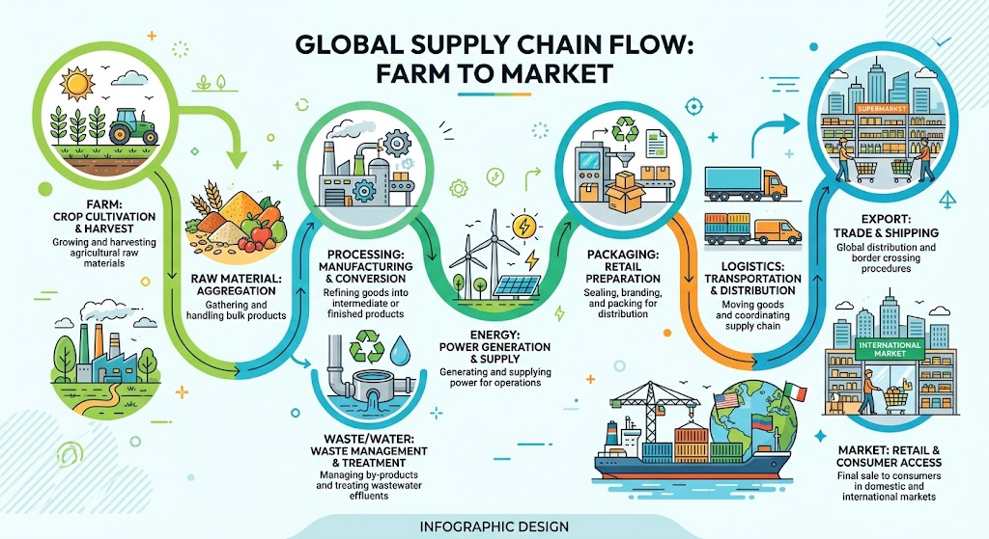
And at every stage we should be able to answer:
What happened?
Where did it happen?
Who was responsible?
What was measured?
Was it compliant?
What was the environmental impact?
What corrective action was taken?
That is the architecture of a smart, climate-resilient food system.
What does Smart Agriculture actually mean?
For us, smart agriculture is not simply putting sensors in a farm. Technology is useful only when it produces better decisions. A genuinely smart agricultural system should help farmers and agribusinesses understand:

Water
How much water is being used? Where is water being wasted? What happens during drought or heavy rainfall?

Soil
What is happening to soil health? Are inputs being optimized? Can productivity be maintained without degrading the resource base?

Weather
What are the climate risks? When should planting, harvesting or irrigation decisions change?

Disease
Can disease or pest risks be detected earlier? Can biological or lower-impact interventions reduce dependence on reactive treatment?

Yield
Can we predict production more accurately?

Traceability
Can we identify the farm, batch, date, inputs and processing path?
That last point becomes extremely important when we move from agriculture into export manufacturing.
The Smart Farm must connect to the Smart Factory
This is the transformation I want to see in the Philippines.
Instead of: Smart Farm + Traditional Factory
We need: Smart Farm → Smart Factory → Smart Supply Chain
The factory should receive better information about its raw materials. The processor should know: expected volume, expected quality, origin, production conditions, timing, transportation requirements, environmental attributes, and potential risks.
This makes manufacturing more resilient. Because when your factory knows what is happening upstream, you can plan. And planning is one of the most powerful forms of resilience.
Advanced food processing should also mean low-impact processing
We cannot build climate resilience by simply increasing production while increasing environmental damage.
Food manufacturing is resource intensive. It uses water, electricity, refrigeration, thermal energy, packaging, chemicals, transportation, and waste-management systems.
Therefore, the next generation of Philippine food manufacturing should pursue low-impact production.
That means designing facilities around:

Energy efficiency
Reduce unnecessary energy consumption and identify opportunities for renewable energy.

Water efficiency
Measure water consumption, reuse water where appropriate, improve treatment systems and protect receiving waters.

Waste minimization
Treat waste as a resource whenever technically and economically viable.

Better wastewater management
Design wastewater systems based on actual process loads and operational requirements.

Cold-chain efficiency
For perishable products, energy-efficient refrigeration and reliable cold storage are directly connected to food security.

Circularity
Recover value from by-products instead of automatically treating them as waste.

Environmental monitoring
Move from periodic paperwork toward continuous or near-real-time information where appropriate.
Food security is also cold-chain security
This is an area that deserves much more attention. When we talk about food security, we normally talk about farms. But food can be produced and still be lost.
Between the farm and the consumer are:
harvesting → transportation → cold storage → processing → distribution → retail.
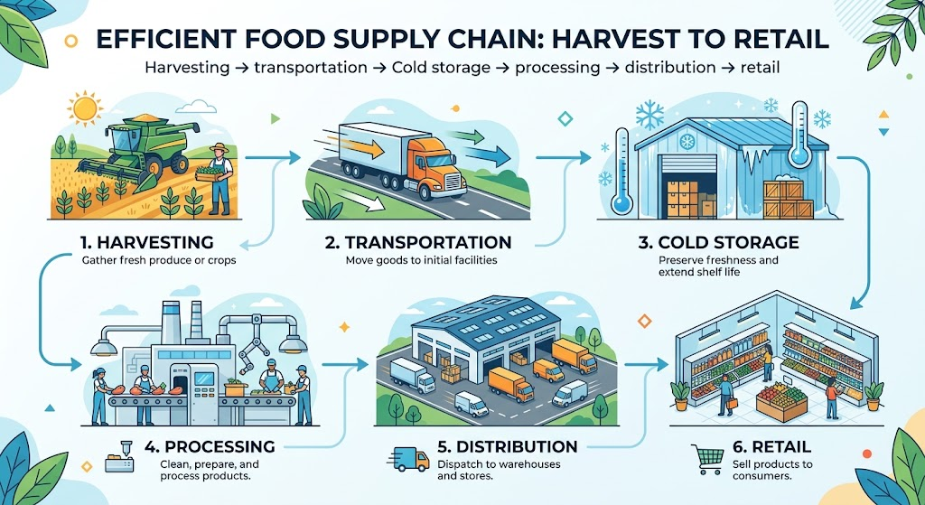
This is why our experience at Envi-Comm includes not only agricultural and livestock operations, but also food manufacturing and cold-chain-related facilities, including ice plants and food-processing facilities. Our company profile includes work involving businesses such as Belcris Foods, ARC Refreshments, Cebu Cube Ice, St. Hallett Food Ventures, The Italian Food Specialists, poultry farms, piggeries and agricultural operations.
That experience has taught me something very simple:
Food security is not only about producing food. It is also about preserving food.
A resilient food system needs resilient refrigeration, water systems, wastewater systems, energy systems and logistics.
Livestock and poultry need the same integrated approach
Poultry and livestock are another important part of this equation. A farm that expands production without planning for: manure, wastewater, odor, energy, water, biosecurity, waste, land use, and environmental compliance is not truly scaling sustainably. It is simply scaling its problems.
We have seen this across the agricultural and livestock projects in Envi-Comm's portfolio, including poultry farms, hog farms, integrated agricultural operations and projects incorporating environmental infrastructure such as wastewater and biogas systems.
The principle is straightforward:
The best environmental problem to solve is the one that never happens.
That is preventive environmental management.
Our proposed solution: The Philippines’ Climate-Resilient Food Manufacturing Ecosystem
If we are serious about transforming the Philippine food industry, we propose building a national ecosystem around six connected layers. A more detailed and comprehensive proposal will be released soon. It summarizes below:

Layer 1 — Smart Agriculture
Deploy practical technologies for: market data, weather monitoring, soil monitoring, water management, crop intelligence, disease detection, yield forecasting, and farm traceability.
The objective is not technology for technology's sake.
The objective is predictable raw-material supply.

Layer 2 — Climate-Resilient Production
Build agricultural systems that can withstand: drought, extreme rainfall, typhoons, heat, pests, diseases, and water stress.
Resilience should become a production KPI. Not just yield. Not just revenue.
Yield + reliability + resource efficiency + resilience.

Layer 3 — Smart Food Manufacturing
Modernize factories around: energy efficiency, water efficiency, wastewater treatment, waste reduction, efficient refrigeration, renewable energy, process monitoring, preventive maintenance, and circular production.
The goal is: More value per unit of resource.

Layer 4 — Digital Traceability & Compliance
Create a digital record connecting:
Farm → Supplier → Factory → Batch → Processing → Logistics → Export
This should integrate: permits, environmental monitoring, supplier records, production information, laboratory results, traceability, ESG information, carbon data, and corrective actions.
This is where AI becomes extremely powerful. However, AI should not replace technical experts. It should help experts see risks earlier and make better decisions faster.

Layer 5 — Export Readiness
Build export requirements into the production system from day one.
Instead of asking: "Can we export this product?"
We should be able to ask: "Which markets can this product qualify for?"
That is a very different mindset. The Philippines should develop market-ready production systems, not merely products.

Layer 6 — Climate & Environmental Impact Measurement
Finally, measure what the system actually achieves.
We should be able to quantify: emissions avoided, water saved, waste diverted, wastewater treated, energy reduced, production losses avoided, raw-material reliability, compliance performance, and export readiness.
This turns sustainability from a corporate presentation into an operating metric.
This is where an integrated platform becomes powerful
At Envi-Comm, we are building toward exactly this type of ecosystem.
Our platform strategy combines:
Regulatory Compliance + Environmental Data + AI + IoT + Engineering + ESG + Climate Solutions.
The existing Envi-Comm ecosystem already includes environmental compliance, engineering and sciences, IoT sensors and monitoring, AI, wastewater and water-treatment capabilities, EPR support, training and other environmental solutions.
Our current strategy also includes partnerships around industrial IoT and real-time ESG data, including the development of ESG Pulse with Cubeworks.
This is important because the future isn't going to be: Consultant + Spreadsheet + PDF.
The future is: Data + Intelligence + Expert + Action.

We need a new definition of Philippine competitiveness
For decades, we have asked: Can we produce it cheaply?
Then: Can we produce enough of it?
Now the question is becoming: Can we produce it reliably, sustainably, traceably and at global standards?
That is the competitive battlefield. Our advantage cannot simply be cheap labor. It cannot simply be abundant land. It cannot simply be a tropical climate.
Our advantage must increasingly become:
high-quality raw materials + resilient production + efficient processing + digital traceability + environmental performance + global compliance.
That is how we move from being a commodity supplier to becoming a trusted global food manufacturing partner.

The Philippines should move from "Made in the Philippines" to "Trusted Globally"
This is perhaps my biggest message for this discussion. We should be proud of Made in the Philippines. But the next evolution should be:

Grown Responsibly in the Philippines.

Processed Efficiently in the Philippines.

Verified Digitally in the Philippines.

Trusted Globally.
Imagine a buyer in Japan, Korea, Europe, the United States or another market scanning a product and being able to verify: where it came from, how it was produced, who processed it, how it was transported, what standards were followed, what environmental controls were applied, and what evidence supports the claims.
That is not just traceability. That is trust infrastructure.

We also need to connect small farmers to this system
There is one critical issue.
We cannot build an export-oriented food system that only benefits large corporations.
The Philippines has millions of farmers and agricultural workers.
The technology architecture must therefore be designed so that smallholders, cooperatives and SMEs can participate.
That means: shared digital infrastructure, cooperative-level sensors, common processing facilities, shared laboratories, shared cold chains, shared traceability, accessible financing, technical assistance, and market linkage.
The goal should be to make global compliance an enabler rather than a barrier.
If we get this right, compliance can actually help smaller producers enter higher-value markets.

Government, industry and technology must work as one ecosystem
No single organization can solve this. The government has the policy, regulatory and agricultural development mandate. Farmers have the land, knowledge and production capability. Food manufacturers have the processing infrastructure. Logistics companies have the supply-chain capability. Technology companies have the digital infrastructure. Financial institutions have the capital. Universities and research institutions have scientific capabilities. Environmental companies have compliance and sustainability expertise. And entrepreneurs can connect these pieces.
This is why I believe the future is not about one company having all the answers. It is about building the ecosystem that connects the answers.

The Philippine opportunity is much bigger than food security
If we solve this correctly, the result isn't only more food.
We create:

More resilient agriculture because farmers have better information and better production systems.

More competitive manufacturing because factories operate with greater efficiency and predictable inputs.

More export opportunities because products become easier to verify and qualify for international markets.

More rural economic development because value-added processing happens closer to production areas.

More investment because investors can see measurable performance and risk.

Better environmental outcomes because water, waste, energy and emissions become measurable and manageable.

Greater climate resilience because the entire supply chain becomes more capable of absorbing shocks.

That is the bigger opportunity.

Our call to action
We believe the Philippines should pursue a national strategy around:

Smart Farm → Smart Factory → Smart Supply Chain → Global Market
And every step should be connected by Data.
We need to make environmental compliance digital.
We need to make traceability digital.
We need to make climate risk measurable.
We need to make sustainability operational.
We need to make export readiness continuous.
And we need to make environmental performance part of the business model—not an afterthought.

The Envi-Comm position
At Envi-Comm, we believe compliance is the starting point, not the destination.
Our mission is to empower organizations to go beyond environmental compliance and accelerate the transition to a sustainable future by building an ecosystem of integrated expertise, technology and ESG solutions.
For the food sector, that means helping connect the environmental reality of the farm with the operational reality of the factory and the compliance reality of the global market.
Because ultimately, climate resilience is not just about reducing emissions.
It is about keeping the system working.
Keeping the farm productive.
Keeping the factory operating.
Keeping food safe.
Keeping supply chains moving.
Keeping communities employed.
Keeping exporters competitive.
And keeping our natural resources productive for the next generation.
That is why I see the future of Philippine food manufacturing not simply as more production.
We see it as:
More resilient production.
More intelligent processing.
More efficient use of resources.
More transparent supply chains.
More measurable environmental performance.
And more globally trusted Philippine products.
The Philippines already has the raw materials, the entrepreneurs, the farmers, the manufacturers and the markets.
What we need now is to connect them.
The farm is the first factory. The factory is the bridge to the global market. And data is the infrastructure that connects them.
If we can build that system, we don't just make Philippine food more climate-resilient.
We make Philippine agriculture and food manufacturing globally competitive for the next generation.

